Lab Plan – 3: Flutter UI Basics and Widgets
Objective: The objective of this lab is to introduce students to the basics of Flutter, including project creation, widget usage, AppBar customization, UI design using rows and columns, handling spacing, and working with images (assets and network).

Task 1: Create a Flutter Project
- Open VS Code.
- Use shortcut:
  - Ctrl + Shift + P → Flutter: New Project
- Name your project and set up folder location.

Task 2: Create a Stateless Widget and Add AppBar
- Use shortcut stle to create a Stateless widget.
- Add an AppBar inside a Scaffold widget.
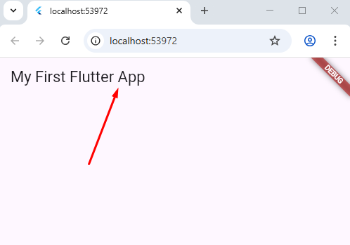

Task 3: Change the Color of AppBar
- Modify the backgroundColor property of AppBar.
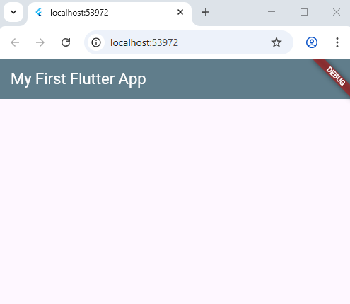

Task 4: Align the Text in AppBar to Center
- Use centerTitle: true in AppBar.

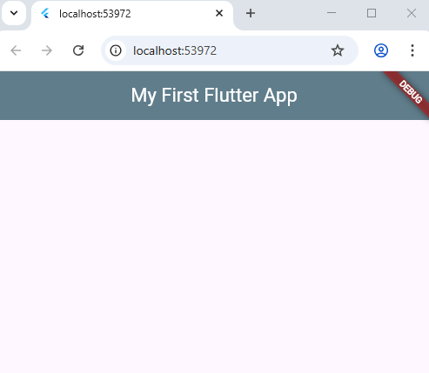

Task 5: Add Your Name at the Center of the Screen
- Use the Center widget in the body section of Scaffold.
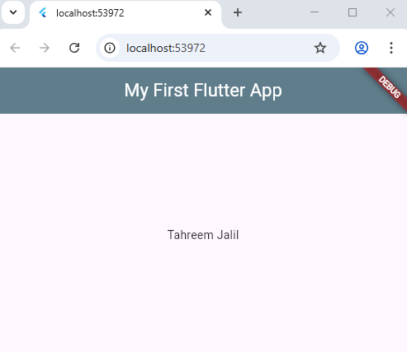

Task 6: Design the UI Layout
- Inside the Scaffold, create a Column widget.
- Add a Row widget as the first child of Column.

Task 7: Use SizedBox for Spaces
- Insert SizedBox(height: --) or SizedBox(width: --) to manage spacing between widgets.

Task 8: Work with Images
(a) Add Assets Images
- Download an image from Google.
- Save it inside the assets/images/ folder in your project.
- Update the pubspec.yaml file: By using Ctrl+S or click Pub get
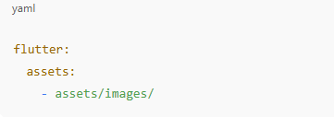
(b) Add Network Image
- Use Image.network("URL") to load image directly from the internet.

